***Demonstration 6***

***Boyle’s Law***

***OBJECTIVES***

The objective of this demonstration is to verify Boyle's Law, which states that *at constant temperature the volume of a gas varies inversely with pressure.*

***INTRODUCTION***

Gases have several properties unique from those of liquids and solids. According to the Kinetic-Molecular Theory of Gases, (a) gas particles (atoms or molecules) are randomly moving with no attractive forces among themselves, (b) gases are compressible, and (c) collisions of the gas particles with the wall of their container result in what is known as gas pressure.

According to Boyle’s law, if the initial volume of a contained gas is V1 at a pressure of P1, the volume will change to V2 when the pressure changes to P2. The relationship between the two volumes and the two pressures will be as follows, if the temperature is held constant:

 …………………………… (1)

Breathing is an illustration of Boyle’s law. During the breathing process, the pressure of the air in the lungs changes as the diaphragm contracts, allowing air to enter the lungs. When the diaphragm moves up, it affects the volume of the lungs, which expels the air out of the lungs.

*Question1: Is the temperature constant during the breathing process?*

A mercury **Barometer** is used to measure the atmospheric pressure. *The instructor will demonstrate the principle of the barometer if available.* The units of pressure are; atmosphere (atm), mmHg, torr, and inHg. At sea level, 1 atm = 760 mmHg = 760 torr = 29.9 inHg.

Atmospheric pressure is affected by altitude, therefore, a typical barometer reading in Cedar City is ~ 618 mmHg.

A **manometer** is used to measure the pressure of a gas in a closed system, such as the pressure in an aerosol can or a balloon. *The instructor will demonstrate the use of the manometer available to measure the pressure of air trapped in a 12” balloon.*

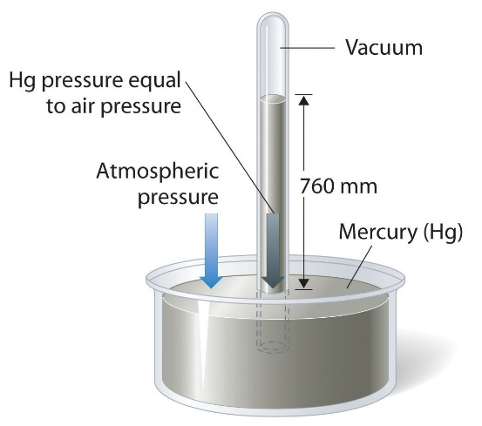 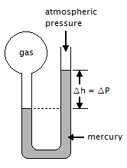

1. (b)

Figure 1: Illustration of (a) barometer (b) open manometer

In this demonstration, the volume and pressure of a gas (namely air) contained in a cylinder is measured (V1 and P1). The volume of air is then decreased by the addition of a liquid to the cylinder, and the volume and pressure of the air under the new conditions (V2 and P2) are measured. The ratios  and  are compared to test whether equation (1) holds.

EXPERIMENTAL PROCEDURE

The instructor will assemble an apparatus that can be used to verify Boyle’s law. The apparatus consists of a reservoir connected to a cylinder so that a nonvolatile liquid may be introduced. A mercury manometer is also connected to the cylinder so that the pressure of the gas may be measured. The initial volume of air in the cylinder (V1) is simply the volume of the cylinder.

*Question 2: How can this be determined?*

The initial pressure of air in the cylinder is atmospheric pressure (P1), which can be measured using a barometer.

In order to decrease the volume of air, the liquid in the reservoir is allowed to flow into the cylinder and the volume of air decreases by an amount equal to the volume of liquid added. An estimated 35-45 mL of liquid should be allowed to flow into the cylinder. This results in a pressure increase in the cylinder, which can be measured with the manometer. The final pressure, P2, is computed from the barometric pressure and the manometer reading.

*Question 3: How can the final volume of gas in the bottle, V2, be measured?*

***DATA SHEET:***

P1 (barometer reading)____________ mmHg

Manometer reading after addition of liquid. ____________ mmHg

P2  ____________ mmHg

Volume of liquid added ____________ mL

V1 ____________ mL

V2 ____________ mL

 ____________

 ____________

*Question 4: Compare the ratios*  *and* 

*Question 5: Do the results support Boyle's Law?*

*Question 6: Sketch a diagram that represents the apparatus used in the demonstration and name all the parts.*

*Question 6: A gas occupies 2.50 L at a pressure of 760 mmHg. What will the new volume of the gas be if the pressure is doubled while the temperature is kept constant?*

*Question 7: Convert the following:*

*2.00 atm = ________ mmHg*

*720 torr = ________ atm*

*Question 8: The pressure on a 120 mL volume of gas is decreased from 1000 torr to 800 torr while the temperature is kept constant. What is the new volume of gas?*

*Question 9: In reference to Figure 1 b, if the atmospheric pressure is 750 mmHg and ∆h is 5.0 cm. What is the pressure of the gas in the flask? (Hints: ∆h is the difference between the atmospheric pressure and the gas pressure in the flask)*